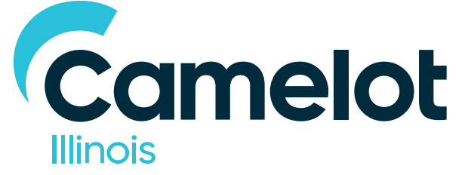

Appendix D: Live Assignment

MAY 3, 2019

Table of Contents:
- Company Background..…………………………………………....3
- Segmentation Overview..………………………………………….6
- Product Portfolio .…………………………………………………….9
- Responsible Gaming.……………………………………………….11
- Pitch Assignments
5.a. Part 1A …….……………….....................................11
5.b. Part 1B …………………………………………………………11
5.c. Part 2 …………………………………………………………..12
- General Considerations …………………………………………..14

- Company Background:

Camelot Illinois was selected by the State of Illinois to be the private manager for the Illinois Lottery. As such, Camelot has agreed to a Private Manager Agreement between itself and the State to manage all marketing, Instants and Draw game development and iLottery (web and app) properties associated with the Illinois Lottery.

Camelot Illinois is a subsidiary of Camelot Lottery Solutions (CLS), a leading technology and professional services provider to lotteries around the world. The CLS portfolio of work includes the UK National Lottery, Irish National Lottery, Loterie Romande, the California State Lottery, the Kentucky Lottery, the Arkansas Scholarship Lottery, among others.

Camelot is committed to restoring transparency, integrity and responsibility to the Illinois Lottery. In partnership with the State, Camelot will operate a modern lottery that truly benefits the people of Illinois. Our innovative approach places consumers and social responsibility at the core, providing funding for schools, capital projects and special causes. We are committed to building an organization with the strength and experience to grow the lottery and reinforce its rightful position as a force for good.

Camelot Illinois is focused on building stronger brand demand, greater consumer
understanding and a stronger emotional connection for consumers with the Lottery. Building strong relationships with players and making the Lottery easier to access and more convenient to play will create a sound foundation for growth and greater participation.

Camelot Illinois hopes to achieve this by:
  - Revitalizing the brand for consumers and stakeholders.
  - Providing compelling reasons to play lottery games.
  - Understanding, then building stronger relationships with consumers.
  - Providing greater access and convenience for consumers.

There are approximately 12 million adults in Illinois (US Census Bureau) and of this, around 6.1 million play the Lottery over the course of a year. Awareness of the Lottery is high and there is strong brand recognition. However, consumers are apathetic toward the Lottery, which highlights an opportunity for future engagement and greater player conversion (Camelot research, Incite, 2016).

Around 1.5 million of the Lottery’s total player base play weekly (i.e., considered core players) and make a sizable contribution toward total sales while 1.8 million have become lapsed players. In FY18, annual sales totaled $2.9 billion. Around $2 billion (68%) came from weekly players. This shows the importance of preserving the loyalty of this segment to maintain a solid foundation for growth while identifying ways to acquire new players. While we are committed to maintaining statewide media coverage/presence, 70% of our sales from FY18 came from the Chicagoland area.

Qualitative and quantitative research determined three significant related growth levers linked to the Lottery brand: brand trust, benefits to society and win belief.

  - Brand trust: The success of all lotteries is underpinned by trust. Previous tracking research showed that brand trust perceptions fell from 2013-2016 but recovered in 2017 after suspension of prize payouts had been resolved. Moving forward in FY19, our tracking trend line has been reset, through there is still much work to be done to improve trust and connection to our brand. Initially, we committed to building the brand through advocacy, loyalty and appeal, though only 29% of consumers would advocate for the Illinois Lottery, 30% of consumers have a strong brand connection, and 50% of consumers find the lottery appealing. Additionally, only a few (12% of consumers) think the Illinois Lottery is “fair and transparent” and 7% believe the lottery “will fulfill its promises.” As such, the Illinois Lottery brand must take swift and continued action to improve long-term advocacy, loyalty and appeal. It must focus on making sincere connections with consumers, highlighting the benefits the Lottery can provide them and the State.

  - Benefits to society: The Illinois Lottery is intrinsically linked to the State for better or for worse in the minds of consumers. Based on previous tracking research, the Illinois Lottery’s link to education fell between 2013 and 2016 but appeared to recover by 2017. Resetting our tracking trendline in FY19, we are still not seen as an advocate for the state or its residents, as only 24% think the “Illinois Lottery does good for the state of Illinois.” Further, there is even more work to be done on a customer relationship management front, as only 7% of consumers perceive the Illinois Lottery is socially responsible and 6% think that we care about our customers.

Illinois lottery profits go to the Common School Fund, Capital Project Fund and multiple other good causes across the State, but most Illinois consumers aren’t aware of this. The benefit to society needs to be more widely understood by Illinois consumers and we need to be more transparent and do a better job of communicating where the funds are going.

  - Win belief: The idea that it’s possible to win the lottery is the key product offering that consumers need to feel in order to consider playing for the first time and continue to feel in order to maintain their level of play. According to the LRW foundational research from our segmentation study in FY19, we see a lack of win belief remains a top barrier for many consumers to play the lottery. This is concerning as a growing and evolving gaming market in Illinois could potentially present serious competition for the Lottery. We need to continue measuring win belief via our continuous brand tracker and make strides to improve the low levels as demonstrated by current perceptions: 27% of consumers state the lottery “makes me feel like I could be a winner,” 21% state feeling like “anything is possible,” and 17% state the lottery “makes me feel lucky.”

There are other factors negatively impacting the relationship between the consumer and the Lottery brand:
  - Game comprehension: Lottery game propositions and the roles games play in the portfolio are unclear to consumers, which can be intimidating and pose a barrier to entry.
  - In-store environment: Consumers highlighted opportunities to enhance their Lottery purchase experience at retail stores.
  - iLottery marketing investment + consumer awareness: Little effort has been made to promote the iLottery platform in recent years. The lack of investment has undermined awareness and conversion, resulting in low registrations. iLottery represents only 1.5 percent of total sales. Players have not been trying iLottery, and when they do, they don’t stay active.
  - Lottery advertising: Our lottery advertising over the past several years has been product focused rather than laddering up to a cohesive brand message. In the next fiscal year, we will be creating a master brand campaign that can highlight various products rather than creating product focused advertising. We’ve also been heavily reliant on traditional media vehicles and have slowly been moving toward more contextually relevant and targeted digital messaging. Further, we plan to maximize marketing and media spend efficiency by leveraging insights to reach our consumers in the most relevant channels. To achieve this goal, we will overlay sales data and customer segmentation with PRIZM data to deploy marketing content in the media channels where our target segments “live” at the end of FY19.
  - Understanding our consumers: Camelot realized there was an immediate need to better understand our consumer base, and how to best interact with them in both messaging and media. Our Insights team has strategically framed Illinois residents into meaningful and actionable consumer groupings (i.e., segments). Of the six segments we have identified across the state, five present opportunity to grow the Illinois Lottery, but to varying degrees as it relates to near-term and long-term business strategy.

- Segmentation Overview:

Below outlines the segments Camelot will prioritize media targeting efforts towards (based on claimed behavior), supported by their opportunity to grow the Illinois Lottery.

  - 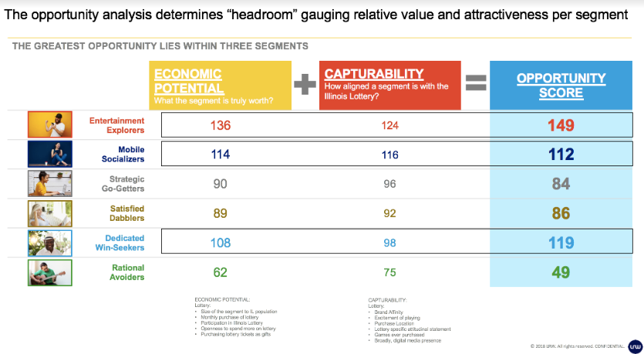
  - 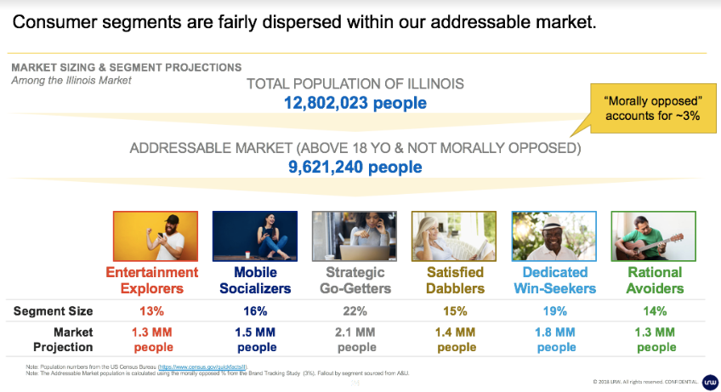
  - 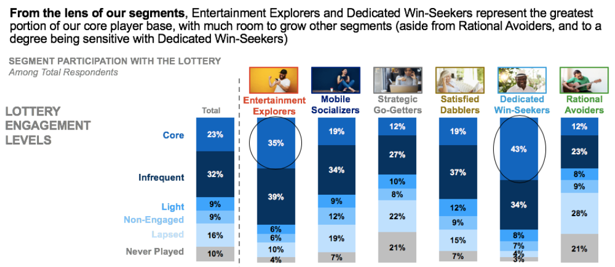

    - Expand the Core by reaching our “Entertainment Explorer” Segment: With the greatest amount of “core” players of any segment, it also represents the most “headroom” for incremental growth demonstrated by their very strong “opportunity score” (136 index score or 36% greater opportunity relative to other segments), which is by far the strongest of any segment. Their opportunity score is broken down to strong economic potential (124 index or 24% above average) and very high capturability (149 index or 49% above average) relative to other segments. While there is a wealth of opportunity with this segment, the main risk is losing their engagement to a competing form of gaming or entertainment, given they are hyper-engaged with various types of activities, predominantly on-site Gambling, VGT’s, Online Gambling and Fantasy Sports, which they generally plan to spend more on in the next year also.
    - Maximize New Growth Opportunities: The Mobile Socializers segment (near-term/easy-win) & Strategic Go-Getters segment (longer-term, challenge) present areas of potential sales growth. From a targeting standpoint, these two segments share some important commonalities, predominantly that they are infrequent lottery players who tend to be younger, interested in games of strategy (or the illusion thereof), digital/mobile savvy, and attracted to a brand they have positive feelings about and are strongly connected to. However, from a strategic planning standpoint, there are more noteworthy differences that make these segments stand apart on their near-term potential relative to longer-term potential growth.
      - Mobile Socializers: Right behind Entertainment Explorers are the Illinois Lottery’s next greatest opportunity for growth – primarily for new growth. While currently comprised of mostly infrequent lottery players (i.e., playing every one to three months) without much brand connection to the Illinois Lottery, they show strong potential if we can meet their needs known to drive strong brand connection (e.g., most important universal needs for connection: part of my regular routine, helps me relieve stress, lifts my mood, as well as secondary drivers of connection such as helps me relive family traditions, a fun challenge, and fear of missing out). Future looking, their incremental growth potential is demonstrated by their strong “opportunity score” (114 index score or 14% greater opportunity relative to other segments), which is equally driven by their strong economic potential and capturability relative to other segments. As the lottery stands in the minds of Mobile Socializers, they show small increases in lottery participation in the coming year. However, they show a very strong propensity to play the lottery online via iLottery (69% of Mobile Socializers indicate “The lottery would be fun to play on the internet and via mobile apps” which is quite high relative to other segments). Competitively, this segment primarily engages in Mobile Gaming, Online Sports Betting, and Fantasy Sports but they don’t intend to spend much more on these activities in the upcoming year relative to what they currently spend.
    - Hold the Core: Dedicated Win-seekers are the segment that is composed almost entirely of what we consider ‘core’ players. They will continue playing the lottery frequently if the offering remains consistent. Our messaging needs to focus on the positive elements that center on the tradition of play (family ties). However, we should not over-message to this group, as we need to make sure we are promoting responsible gaming. This group tends to skew lower income, are racially diverse, skews older, and are risk-takers who are "in it to win it". When optimizing our offerings (via game development or channel), this group can be used as a sounding board to ensure their core involvement remains intact.
    - Future Consumer Insights Analysis:
      - Consumer journey and Channel mix: To better understand where consumers are making purchase decisions and how to best reach them at various locations, Camelot Illinois plans to conduct a Path2Purchase study and Marketing Mix Model in the second half of the FY19 to better inform media strategy in retail, app, and web.
      - Digital Segmentation: Camelot is creating a digital behavior-based segmentation model. It will identify key factors for success in acquiring & retaining consumers, increasing play frequency and encouraging game cross-sell opportunities. Our goal is to determine where there is opportunity to influence consumers purchase behavior with digital messaging across email campaigns and digital paid media. A draft of this model has been created based on historical data and will be evolved now that our new fully tagged site was launched in February. It will be available for use by the selected agency.
- Product Portfolio:

The Illinois Lottery product portfolio is comprised of two main entities: Instant Tickets and Draw Games.

  - Instant Tickets: A variety of instant games are available from the Illinois Lottery, ranging in price from $1 to $30. They offer players the opportunity to win instantly and to play at their leisure. Instant game tickets are preprinted with a latex surface partially covering the face of the ticket that can be scratched off to reveal potential prizes. For this reason, instant games are sometimes referred to as scratch-off games. In the past year, nearly half (49%) of all Illinois residents have played an instant ticket. This is a highly impulse driven category, with the majority of purchases occurring at gas stations, c-stores, and independent retailers.

New instant games are introduced monthly, with tickets at several price points across a variety of themes – Extended play (Crossword, Bingo), Cash, Luck, Numbers, Whimsical, Seasonal, Licensed, etc. Some games are launched as “families” where the same look and feel are established across multiple price points to allow for specific promotions to reach across multiple tickets, minimizing the spending risk and maximizing the player reach.

One way the Lottery supports good causes in the state of Illinois is by offering Special Cause instant tickets. 100% of the proceeds from the sale of these tickets goes directly to a specific cause. Currently, the Illinois Lottery offers tickets for the following causes: breast cancer research, Illinois veterans, Illinois HIV/AIDS research, the Police Memorial Fund, Special Olympics in Illinois, The MS Foundation, and a ticket to combat homelessness in Illinois.

Currently, all Instant Tickets must be purchased in retail and are not available for purchase on any iLottery properties. However, there is discussion about legislation being passed in the near future that would allow digital parity with retail for Instants.

  - Draw Games: A draw game is a lottery game that has a specific drawing date and time,
players can choose their own numbers and results are made available to the public. Players choose their numbers or choose quick pick and hope that the numbers on their purchased ticket match the numbers drawn. The Illinois Lottery offers two types of draw games: Jackpot games and Numbers games.

Jackpot games consist of two multi-state games (Powerball and Mega Millions) and two Illinois in-state games (Lotto and Lucky Day Lotto). The top prize, or ‘jackpot’, vary per each game. If the jackpot prize is not won in a drawing, it ‘rolls over’ to the next drawing (the jackpot increases by a fixed sales percentage for multi-state games and by a fixed dollar amount for in-state jackpot games). Illinois Lottery jackpot games are games in which the player selects a specific amount of numbers from a preset range of numbers. Jackpots and other prize tiers are pari mutuel, therefore they are shared between multiple winners.

Numbers (or pick)games are drawn twice a day, every day of the week, including Sunday. Pick 3 and Pick 4 are daily games (drawn twice daily). To play Illinois Lottery Pick games, the player selects a specific amount of numbers from a preset range of numbers. The primary difference between jackpot games and numbers games is that the prizes for numbers games are set amounts; they do not change from day to day or draw to draw and they are never pari mutuel.

All draw games can be played via play slip, Quick Pick, or manual entry by a store clerk of a player’s numbers. Just before each drawing there is a ‘draw break’, a short period of time when tickets cannot be purchased for that drawing (so that wagers may be accounted for and the winning numbers drawn).

Below is the current draw Schedule:

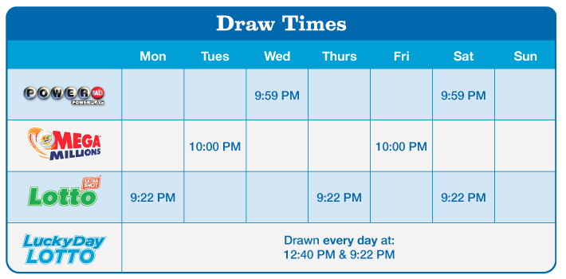

All Illinois Lottery draw games are available for sale at both retail and via iLottery properties (website and app). Per current legislation, players can purchase a single draw/ticket for Mega Millions, Powerball and Lotto via iLottery properties. All other games purchased on iLottery platforms must be sold via a minimum seven-day subscription (Lucky Day Lotto, Pick 3 and Pick 4).

- Responsible Gaming:

The Illinois Lottery appreciates the unique obligation publicly sponsored gaming programs have to protect players and provide gaming entertainment with the highest standards of social responsibility. Applying responsible gaming and consumer protection best practices, the Lottery operates under procedures that emphasize our core values of integrity and responsibility.

Media plans should always consider responsible gaming when determine how to best approach all audiences.

- Pitch Assignment:
  - Part 1a: Media Plan Cost Out
For fiscal 2019, we purchased “foundational” media for a six-month period with the intent to lock in inventory and gain buying efficiencies. Attached (Appendix E) are details of components of our media buy for the first half of FY19 (July – December).

If you were to replicate these plans – buy the same media inventory as in Appendix E with the same timing – what would your net media cost for these plans have been? In answering this question, please provide net media costs for each media channel in aggregate (i.e., network TV, cable TV, Out of Home) for the full 6-month period. Costs by month are not needed, nor is pricing for each individual placement. If you are unable to mirror this inventory exactly, please provide alternate placements. In the event of alternate placements, please call these out in your response. Additional instructions for this test and an output template are included within Appendix E.

  - Part 1b: Strategic & Tactical Recommendations
Attached for review in Appendix F is a summary of our entire foundational media buy for the first half of FY19 (July – December). If you had a clean slate, what changes in the media execution would you recommend based on your understanding of our business strategies, objectives and challenges and your own views of the contemporary media landscape?

At a minimum, your response should address the following (the extent of detail you provide is up to you):
    - Your thoughts on how the various media channels can be best employed to effectively reach our targets to progressively move them through the purchase funnel.
    - How can we use media tactically to not only reach our targets effectively but to strategically differentiate our various products from our master brand?
    - Considering the fact that 65% of our portfolio is comprised of Instant tickets that can only be purchased at retail, what tactics would you deploy to reach the consumer closer to the point of sale in as targeted a way as possible?
    - We took this approach to always-on media to lock in inventory, gain buying efficiencies, and reduce cost. Throughout the year, we supplemented the foundational buy with incremental dollars to further support specific initiatives with alternate media tactics relevant to the campaign (influencer marketing, seasonal activations in terrestrial media, etc.). Would you recommend a similar strategy?

  - Part 2: Develop a media plan to support the launch of our new iLottery mobile app
Consumers in Illinois are largely unaware that they can play the Illinois Lottery draw games via desktop or mobile app. When tested, awareness of the app was quite low, and digital channels currently account for less than 2% of total sales. Historically, these channels were not advertised effectively at launch; upcoming campaigns should address issues of awareness while also driving download and increasing overall iLottery registrations and game sales.

The new Illinois Lottery website and app will provide improved functionality, accessibility and convenience related to playing and winning across the Lottery draw game portfolio. At launch, the App will offer different value propositions to both Digital and Retail players:

    - Digital players gain:
      - A streamlined, modern app
      - Security features include fingerprint ID and facial recognition
      - Play on the go / never miss a big jackpot / push notifications
      - Prizes (under $600) are deposited into their online account (wallet) instantly
      - Ability to quickly play, pay and retain your winnings

    - Digital + Retail players gain:
      - Ability to scan your tickets to see if you're a winner
      - Map of retail stores near you via Store Locator
      - Alerts of big jackpots / New product announcements

The improved functionality and ease of use provide convenient access and the ability to quickly respond to other Lottery communications focused on the app (e.g. download the app after seeing a TV ad, OOH communication, etc.) Consider integrated experiences that bring the app to life across multiple forms of both traditional and digital media that not only let users know the app is available, but also inspire them to use it. Consider positioning ad units that seamlessly encourage download and game sales, limiting the amount of actions between initial touchpoint and conversion.

This campaign should deliver a digital first narrative with emphasis on linking all activity back to mobile with a focus on all games that are currently sold online: Powerball, Mega Millions, Pick 3/Pick 4, Lotto and Lucky Day Lotto. Showcasing ticket scanning and connectivity between retail experiences and digital app is also an important component of the go to market strategy.

While most of the campaign highlights the app, we want to be sure we don't forget about the website and ability to play via desktop. We want to encourage digital play, whether via the app or website, but the app has better features to highlight in campaigns.

  - Business Objectives: To successfully launch the Camelot iLottery App via:
    - Increase awareness of the digital platforms, emphasis on the App
    - Drive registrations, downloads and active players (both retail ticket scans and iLottery players)
    - Develop and maintain consistent dialogue with digital players with the aim of encouraging increased trial/frequency of play through the App (to be supplemented via push notifications and Email campaigns)
    - App downloads: 200k within 6 months of App launch; experiential, sports, this media campaign and halo from web campaigns will all contribute to this total
    - Weekly ticket scans: 400k per week
  - Across all channels, tactics should:
    - Drive online Download/Registration/Download
    - Drive Frequency of online play with call to action that drives to site
    - Drive Trial by retargeting Site Visitors with call to action that encourages Play (Phase I tactics should ladder into frequency of play/usage in Phase II)

  - Budget:
    - $2.2M across all channels (net)

  - Timing:
    - Campaign will be live for 3 months
    - Assume campaign will be live from July through September

  - Strategic Target:
    - Adults 18+ Geo-fenced to Illinois only
    - Campaigns should address Core, Infrequent and New Players

  - Media considerations by Channel (the below addresses where we know we need to be live at a minimum; if suggesting alternate channels please provide additional rationale in recommendation):
    - Terrestrial TV/Radio:
      - Ensure that broadcast media does not buy in DMAs (Designated Marketing Area)/MSAs (Metropolitan Statistical Area) that have spill-over to other states
      - When sharing your recommendation, share the daypart mix for broadcast channels and rationale for recommendations
      - Try to align with contextually relevant content within programming and radio sponsorships
    - Out of Home:
      - All units selected must be high traffic, high visibility buys
      - Ensure that there are boards in Springfield
    - Digital:
      - Support the launch of the new iLottery App by driving mid-to-lower funnel paid media tactics across Paid Search, Paid Social, Online Video and Display (can be programmatic or direct, though the Illinois Lottery utilizes a pre-approved site whitelist).
      - Tactics should support awareness, but digital focus should be on driving app download, and, where possible, increasing iLottery game play.
      - Across all digital channels, tactics should:
        - Drive App Download via App Download Landing Page
        - Drive App Download by retargeting Landing Page visitors that visit App Download Landing Page, but do not complete download
        - KPIs (Key Performance Indicators)/Success Metrics:
          - $5 per App Download
          - Target Search CPA (Cost Per Action): No more than $4.50
          - Target Display CPM (Cost Per Million): $8

- General Considerations:
  - Please familiarize yourself with the regulatory environment surrounding Lottery advertising across all channels/partner networks prior to putting forth tactical recommendations. Contact channel level partners to determine all starts/stops specific to category.
    - Make sure that your final plans provide adequate coverage to both Chicago and downstate Illinois.
    - Note that at this time, draw games are the only games able to be purchased via the app.

